Seeds of Change in the College of Forestry (CoF)
Doug Pollock - Sept. 29th, 2019
Broken Trust: I've been a firsthand observer of OSU's forestry management practices in the McDonald and Dunn Research Forests for more than three decades. I've also participated in the planning process, attending OSU's meetings and giving input. In the mid-90s I joined a group of Soap Creek neighbors who were concerned about the College of Forestry's management of the newly-donated Cameron Tract. We met with the OSU President and initiated a public meeting with Dean George Brown and his research forest staff. Scores of neighbors showed up to express a wide range of concerns, ranging from herbicides polluting our wells, erosion from the planned clearcuts, and safety impacts of logging trucks on our narrow, twisty roads. Dean Brown and his staff promised to hold a second meeting to provide answers to our questions. Several weeks later, we all received letters thanking us for our input - and notifying us that cutting would begin soon. There was no mention of the promised 2nd meeting. Thus began my first lesson in how the College of Forestry deals with public input: they tolerate our input, but rarely embrace it; promises mean nothing.
When I discovered OSU had cut 16 acres of Old Growth near Baker Creek in May of this year, a whole new journey of discovery lay before me. Like the plot of some novel of deception and intrigue, the story unraveled in ways that felt both familiar and foreign. The forest manager who adamantly denied they'd cut Old Growth...the phony claims that signs of mortality and rot justified the logging, the bizarre explanation that the road they'd cut into the adjacent Old Growth was for purposes of a "fire break access point"...each revelation and excuse only dug a deeper hole for the Dean and his staff. The lack of honesty and integrity in OSU's response to the cutting only added fuel to the fire of community outrage and opposition. The cutting of Old Growth created enormous mistrust and anger, while the denial and obfuscation by CoF staff further eroded the public trust of OSU.
Community Response: I organized a group of neighbors to form Friends of OSU Old Growth in order to protest the cutting of Old Growth and the College of Forestry's misguided forest management. We developed a website (www.friendsofosuoldgrowth.org ) to advocate for preservation of the remaining, unprotected Old Growth in the forests managed by the College. We were instrumental in getting The Oregonian's Rob Davis to write his extensive expose, "Majestic Douglas fir stood for 420 years. Then Oregon State University Foresters cut it down" (1). The response from the broader community has been overwhelming. We now have over 500 members receiving email updates and more than 1200 signers of our petition. OSU faculty members, alumni, recreational users, and others who care about the forests have come together not only to preserve Old Growth, but also to call for change in OSU's forest management.
I've been even more surprised and gratified by the many CoF insiders (including several emeritus professors) who have contacted me to divulge details of past misdeeds within the College. A former insider gave an account of graft within the research forest management, detailing how more than 700,000 board feet of timber was misappropriated from the Blodgett Forest in the early 90s. The whistle-blower was fired by a former Research Forest Director, and he reported the crime to the Oregon Governor's office. By the time state officials investigated, evidence of the theft had been erased from the College's records. A former employee of the College told of research requests that were routinely used to justify much larger harvests (against the wishes of the researchers). Neighbors told of the CoF's intentional logging of several other areas of Old Growth. A researcher disclosed that a former Dean had declared spotted owls nesting in the OSU forests as irrelevant - opposing OSU's own spotted owl expert. I heard numerous stories of unrepentant hardliners within the CoF who worked to oppose the preservation of Old Growth (including the Baker Creek and Sulphur Springs stands). These hardliners dominated the management practices of the research forests for many decades, giving OSU a dark reputation as a tool of the timber industry. An owner of a forestry consulting business stated he won't even consider hiring OSU Forestry graduates because they are so lacking in appreciation of ecological forestry values. An entire generation of OSU forestry graduates are stumped when asked, "Who was Aldo Leopold?"
OSU's Response: As the story of OSU's cutting of Old Growth gained national attention, the Dean's narrative changed in sadly predictable ways. His initial admission that it was a "mistake" and did not align with OSU's principles, morphed into conflicting variations. He later claimed they were following the principles of their (10-year-suspended) 2005 Research Forest Plan - "just not to a T" (The Oregonian). In a July 23rd CNN.com story, he said, " For years we've had plans that these trees would be harvested, our mistake was in sticking to that (2005) Plan" (2). Recently, the Director of the Research Forests gave a private tour of the 'No Vacancy' clearcut and adamantly stated it was NOT a mistake to cut the Old Growth - that they were following the plan. The same conflicting message is reportedly being told by OSU's team working on the Elliott State Research Forest project with the Oregon Department of State Lands (DSL).
In response to public concerns about OSU's forest management, the Dean and his staff held a public meeting (on August 28th, in Adair Village). Many participants expressed concerned about the unbalanced format of the meeting, following the traditional, "You have the questions, we have the answers" structure. This predictable, outdated response is captured in the following table. Like former Deans, the Interim Dean has resisted requests to change to a more collaborative approach.
The traditional vs. collaborative approach to solving forestry issues (3):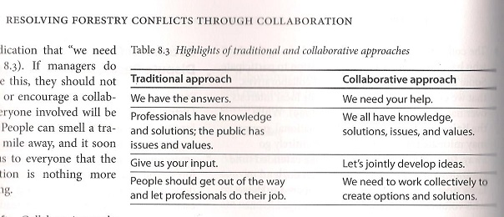
The Dean's chatter about his childhood, sense of place and optimizing forestry to solve the climate and sustainability crisis stood in stark contrast to how he and his staff have been managing the research forests. This disconnect is at the heart of these issues, leaving many folks highly mistrustful. The talk just doesn't match the long history of OSU's forestry mismanagement.
Violations of the Plan: Unfortunately for the Dean and his staff, the many violations of the 2005 Plan are as plain to see as the growing number of clearcuts in the forests. A recent assessment by Debra L. and K. Norman Johnson (4) provides unequivocal documentation of the violations. They detail how the cutting of Old Growth at Baker Creek and numerous other harvests all violated the commitment to maintain the 1,585 acres of nesting/roosting/foraging (NRF) habitat for northern spotted owls. They estimate the total NRF has been reduced by ~166 acres or more than 10% in the past three years. They also point to 10 clearcuts in the South Zone of the McDonald Research Forest that greatly exceeded the 1-4 acre harvest prescription. These are not minor oversights or adjustments - they are wholesale violations of the plan's principles. The Johnsons were involved in developing and implementing both the 1993 and 2005 Research Forest Plans. No one speaks with more authority and credibility when it comes to OSU's forestry plans. For the Dean and CoF staff to insist they are following the principles of the plan is shamefully dishonest.

Faced with such blatant disconnects and dysfunction, it is reasonable to ask how might one go about changing OSU's deeply-entrenched and outdated approach to forestry. With contributions from the timber industry permeating the College and funding the Dean's position, is there any hope of substantive change? Before considering these questions, it is helpful to take a moment to discuss the theory of change in large organizations. In Ecological Forest Management (3), the authors cite work by Gunderson (1995) and Janssen (2002) showing that natural resource policies in the U.S. have evolved in ways that are very similar to biological systems:
Four Phases of Policy Development and Change
- Initial robust policy implementation followed by increasing rigidity over time as the policy matures and bureaucracies become committed to it.
- Challenge to the policy by activities based on differences between expectation and observation, which can create a crisis and lead to policy collapse.
- Catalysts for change taking action, helping create a bridge to a new policy.
- Development of new policy alternatives followed by policy selection and implementation, and the cycle beginning again. (5)
They write:
"Initially robust policies become rigid, often with a single-minded emphasis on maximizing one aspect of resource management. The responsible agency becomes so invested in the policies, and the social forces that benefit from them are so powerful, that the agency cannot adjust as problems and circumstances change. Political and legal activists eventual take actions that result in policy disintegration, followed by individuals and groups whose ideas serve as catalysts for change"(3).

Following in the Footsteps of the USFS: The authors of Ecological Forest Management also cite the highly relevant example of federal forest policy and over-harvesting, leading up to the Northwest Forest Plan of 1994. OSU's College of Forestry seems to be following a similar trajectory:
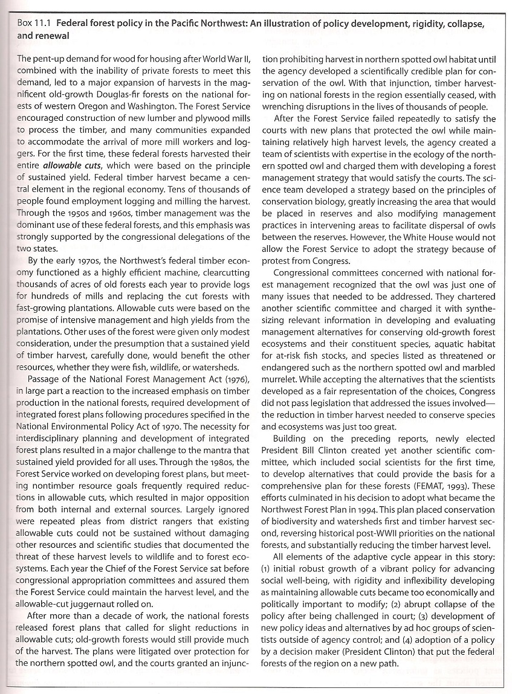
A history of federal forest policy in the Pacific Northwest leading up to the NW Forest Plan (3).
After decades of overcutting by the timber industry and the systemic failures of the Forest Service and Congress to come up with meaningful protections for threatened and endangered species, newly elected President Bill Clinton got involved. The result was the 1994 Northwest Forest Plan which "placed conservation of biodiversity and watersheds first and timber harvest second". An outside decision maker (President Clinton) delivered a new policy which forever changed the path of forestry in the Pacific Northwest (3).
The analogies to the OSU College of Forestry are particularly relevant and powerful - at least up to the point of crisis and dysfunction. As my opening story relates, the managers of the research forests have had a long history of ignoring public input - and even their own carefully developed, inter-disciplinary plans. The last plan was developed in 2005 and the next one isn't expected for at least three more years - a 17-year lapse. The College also operated without an updated forest inventory or GIS staff for a full decade. How can a public entity managing 15,000 acres of land justify operating for so long without a plan and accurate forest inventory?
Priorities of the CoF: Revenue generation has clearly been given priority over other values in the management of the College forests - and the planning process. The Oregonian reported, "$6 million in accelerated timber sales from the school's forest near Clatskanie are being used to help defray cost overruns for ...the Oregon Forest Science Complex"(6). These cuts happened after the Research Forest managers abandoned their innovative 1997 management plan for the Blodgett. The suspension of the Research Forest Plans for both the McDonald-Dunn and Blodgett Forests (last updated in 2005 and 1997 respectively) paints a picture of a decidedly insular organization, focused primarily on revenue generation, not research and education. The failure to incorporate carbon assessments (as called for in the 2005 Plan) or any meaningful changes to forestry practices to reduce climate change is another serious omission.
Lack of Integrity: The lack of transparency and bias toward revenue generation has also characterized the Dean's Tier 1 Advisory Committee, tasked with developing the mission and goals for the next Research Forest Plan. This committee met for nearly two years, with little or no public notice. The committee was given a mandate to come up with $2 million in revenue from timber harvests, arguably biasing their work from the onset. The sole public representative on the committee would not disclose the names of the committee members, apparently upon the direction of the Research Forests Director. It took three separate email requests to get the Dean to disclose the names of the committee members. Key questions about the committee's work remain unanswered after repeated requests to the Dean and OSU's Communication Director. The refusal to answer fundamental questions constitutes a restraint of information and clearly violates OSU's own core values (7):
3) Integrity. We value responsible, accountable and ethical behavior in order to maintain an atmosphere of honest, open communication and mutual respect throughout the Oregon State community.
Genesis of Change: Given the long history of mismanagement, the seriousness of the problems, and the significant pressure from timber company interests and revenue needs, it seems doubtful change will come from the managers of the research forests. Many CoF insiders and alumni tell me change has to come from outside the College - just as the timber industry of the 1980s and 90s only changed when powers beyond their control forced it upon them. We now have growing awareness of climate change and the huge carbon impacts of logging and timber production. This societal pressure on the College's forest management will only increase - both within and outside OSU. Three decades of climate data and consensus among the world's climate scientists (including many at OSU) tell us this is so. Furthermore, citizens increasingly view OSU lands as public lands - and they expect them to be managed for the public good. The public will demand a collaborative role in this process, a change that surely frightens the traditionalists within the College. In addition, the huge power of social media, email, and the Internet mean that OSU can no longer control the dialogue or message. When the story of OSU cutting a 420-year-old tree shows up on the home page of CNN.com, it has a lasting, negative impact on the University.
Seeds of Change: If the OSU administration is truly committed to changing the College of Forestry, it will need to lead the process. Here are some specific steps to take:
- Restore the management plans for the McDonald-Dunn and Blodgett Forests - and follow them to a T. This must be done with a strong public commitment.

- Make the study and mitigation of climate change the highest priority for all College operations. Do detailed carbon assessments (as called for in the 2005 Plan). Stop all burning of logging slash piles. Make the research forests a leading example of ecological forestry management.

- Play the leading role in transforming practices of the timber industry to minimize climate change and prioritize ecological functions through education, research and advocacy. Exhibit this leading role by demonstrating the very best practices (prioritizing ecological values and carbon storage and mitigation) in the OSU research forests.

- Publicly commit to preserving ALL late successional reserves on OSU lands, not just trees over 160 years old. Late successional forests are now largely protected in our federal forests - OSU should be matching or exceeding this relatively low bar. Start by changing the status of the Sulphur Springs stand to protect the remaining 36 acres of Old Growth.

- Disconnect timber industry funding from key positions within the College of Forestry, including the Dean's endowment. This funding presents an enormous conflict of interest, biasing decisions at all levels of the College.

- Fully disclose all sources of funding for the College in an annual report presented to the public. This includes revenue from each timber harvest, donations to the endowments, funding of the new forestry building, research, and education. The public has a fundamental right to know where the money is coming from and where it is going.

- Change the planning process for the next Research Forest Plan to make it a truly collaborative process with public involvement. Make sure that the planning team is NOT biased toward revenue generation, but rather prioritizes ecological values and carbon mitigation and storage.

- Develop an independent assessment process with clear performance metrics to gauge the College's compliance with their forest management plans. Publish the results. Hold a public meeting each year to present the results and discuss management plans for the coming year. Hold public tours on an annual basis to demonstrate management and research activities.

- Choose a new Dean who is truly committed to positive change within the College of Forestry.

- The OSU President, Executive Committees, and Board of Trustees must provide leadership and support for these changes - history has shown change will not come about without high-level support.
-------------------------------------------------------------------------------------------------------------------------------------------------------------
(1): The Oregonian, https://www.oregonlive.com/environment/2019/07/majestic-douglas-fir-stood-for-420-years-then-oregon-state-university-foresters-cut-it-down.html
(2): CNN.com, https://www.cnn.com/2019/07/23/us/old-growth-trees-cut-oregon-state-trnd/index.html

(3): Ecological Forest Management, by Jerry Franklin, K. Normal Johnson, and Debora L. Johnson, 2018
(4): Damaging Ecological Resources Protected by the 2005 Forest Plan: Recent Harvests on the OSU McDonald-Dunn Forest,by Debora L. and K. Norman Johnson, https://friendsofosuoldgrowth.org/latest-news/
(5): Panarchy, by Lance H. Gunderson and C.S. Holling, 2002
(6): Old growth, new questions for OSU, by Rob Davis, The Oregonian, July 27th, 2019
(7): https://leadership.oregonstate.edu/trustees/oregon-state-university-mission-statement

